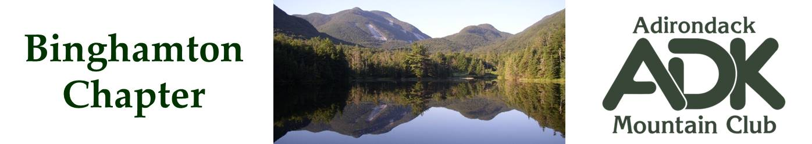

BINGHAMTON CHAPTER OF THE ADK
Meeting Minutes for December 16, 2021

The Chapter Meeting was called to order at 7:10 PM by Chair Pat Connors via Zoom.

The purpose of this meeting was to vote on the slate of officers for 2022

There were no nominations from the floor. Erik Gregory moved that we elect the slate as presented; Pat Connors seconded. The motion was approved and the secretary cast one vote for the slate.

The 2022 officers of the Binghamton Chapter of ADK will be:

Chapter Chair – Pat Connors
Vice Chair – Vacant
Advisory Council Member – Bob Strebel
Secretary – Elaine Gregory
Treasurer – Lindsey Leiser
Outings – Bob Strebel
Communications – Erik Gregory
Webmaster/Membership – Erik Gregory
Hospitality – Vacant
Conservation – Cindy Gretzinger
Programs – Vacant

A discussion was held regarding the Chapter Checking Account. With the election of a new treasurer, all present at the meeting agreed that there should be two signers on the account:
Lindsey Leiser, Treasurer
Pat Connors, Chapter Chair

The meeting was adjourned at 7:25 PM

Submitted By:
Elaine Gregory, Secretary

