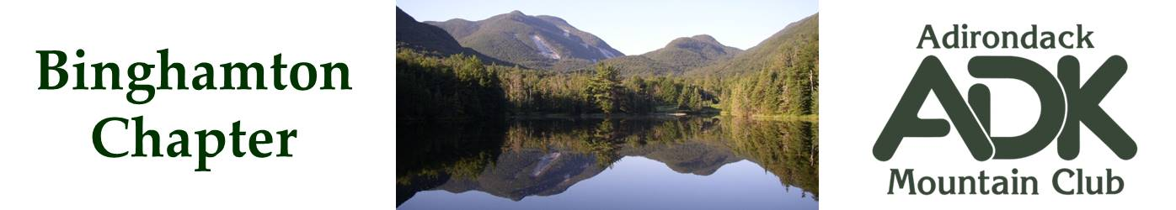

BINGHAMTON CHAPTER OF THE ADK
Meeting Minutes for 9/12/2023

The Chapter Meeting was called to order at 7 pm. Attendees were: Bob Strebel, Erik Gregory, Brooks Getty, Nick and Cindy Gretzinger.

The purpose of this meeting was to discuss Fall Planning activities.

- Chapter Budget for 2024 – Due Sept 20, 2023. Eric to send out proposed budget to Pat and Lindsey.

- Webpage Update discussion – add ADK Rating system for the Patch Challenge, remove Silver Lake Leanto maintenance, include any leanto maintenance as a challenge conservation Patch activity, continue to look at secure email contact methods.

- Black Forest Fall Trip – coming up soon - scheduled for 9/29 to 10/1/2023. Openings still available.

- Conservation Activity -- Broome County Riverbank Clean Up -- Scheduled for October 21st, 9 am to 12 pm. Save the date!

- Winter Outing – JBL Lodge Tentative Schedule for Late Feb/Early March. Group proposes chapter funds half the cost.

- Upcoming Elections proposed for November 14th meeting. Nomination committee was formed: Nick G., Brooks G, and Patsy S. Nominations to be solicited prior to the October meeting. Self nominations accepted.

- Next Meeting to be held October 17th at Chenango Town Hall.

- Fall hikes options were discussed and once details are available can be sent to Nick to post on Facebook and the Webpage.

The meeting was adjourned at 9 pm.

Submitted By: C.Gretzinger

