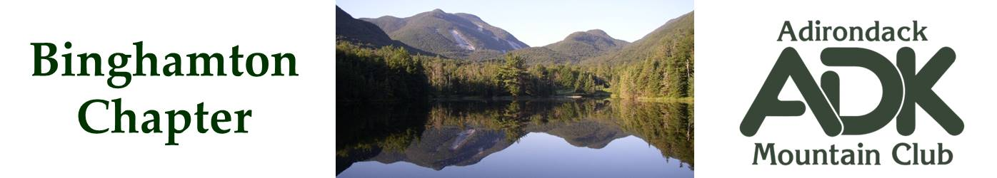

BINGHAMTON CHAPTER OF THE ADK
Meeting Minutes for 10/17/2023

The Chapter Meeting was called to order at 7 pm. Attendees were: Pat Connors, Erik Gregory, Lindsey Leiser, Nick Gretzinger and Cindy Gretzinger.

- Conservation Update. Broome County Riverbank Clean Up -- Scheduled for October 21st, 9 am to 12 pm. Otsiningo Park South. Saturday is the best day for most, despite rain forecasted.

- Lindsey presented the details of the Quick Lake lean-to work project. On Oct 27-29.

- Chapter Budget for 2024 – Due Sept 20, 2023. The Budget has been submitted, Thanks to Eric, Lindsey and Pat.
  - Funding for ½ of JBL Lodge cost was approved.

- Membership – There are approximately 200 Binghamton Chapter Members. The Google Groups site shows 383 emails. An action for next year is proposed to review members up to date with dues.

- Webpage Update discussion – contact info; all present are ok with posting e-mail and phone for events only, most do not like the email popup function that requires entering email password, look into contact link that shows e-mail and phone number as a link.

- Outings trip leader certification. Status of certification reviewed. Cindy sent out email explaining how to get required training after the meeting. It was agreed that it is the job of the Outings chair to check training status of chapter trip leaders, and the job of the Webmaster to ensure posted event leaders have the required training.

- Election nomination period closed with the following nominations.
Position and Current Occupant | Nomination
Chapter Chair – Pat Connors | Cindy Gretzinger
Vice Chair – Vacant | Pat Connors
Advisory Council Member – Bob Strebel | Bob Strebel
Secretary – Elaine Gregory | Nick Gretzinger
Treasurer – Lindsey Leiser | Lindsey Leiser
Outings – Bob Strebel | Bob Strebel
Membership – Erik Gregory | Erik Gregory
Webmaster/Communications – Erik Gregory | Nick Gretzinger
Hospitality – Vacant | Vacant
Conservation – Cindy Gretzinger | Brooks Getty
Programs – Vacant | Lindsey Leiser

- Next meeting will be held Nov 14th at a Copper Top restaurant/bar 6:30PM.
  - JBL and other 2024 events.

The meeting was adjourned at 9 pm.

Submitted By: N. Gretzinger

