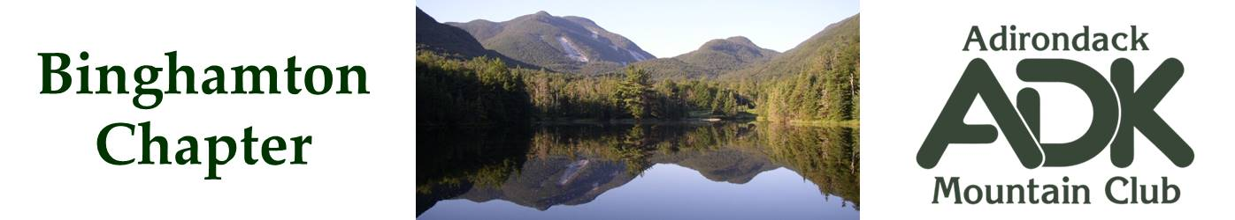

BINGHAMTON CHAPTER OF THE ADK
Meeting Minutes for 2/11/2025

The February chapter meeting was held at the Endicott Public Library. Attendees were:
Lindsey Leiser, Erik Gregory, Brooks Getty, Bob Strebel, Pat Connors, Dave Bailey, Kirsten & Gerard Griffin, Devin McMicken, Greg Wells, Michael Ford, Nick & Cindy Gretzinger.

Meeting discussions:

Membership
- Eric has completed a review of the Google Groups email list, updated approximately 50 new members and purged old emails beyond 2018. The new IMIS system can now be used to check for new members and membership status.

Outdoor Leadership Training
- There is an online zoom course available for the Level 2 Outdoor Leadership 101 course, April 4, 2025. Sign up is on the Main Club website. Chapter members will be reimbursed for the cost of this Level 2 course. Outdoor Leadership Courses for Level 3 need approval from the chapter prior to taking the course.

Chapter Budget
- Lindey reported approximately $2412 in our account. Website has been paid for 2025. JBL final payment is pending.

Outings/Advisory Council
- Bob reported that there are new Release of Liability and Accident Report forms coming out soon. These will need to be posted to our website when available.
- February 24, 2025 is Lobby Day in Albany. ADK members are welcome to attend.
Events/Trips
- Johns Brook Lodge Winter Trip is 3/7/25 - 3/9/25. Bob reviewed equipment required and details for the trip members.
- Adirondack Loj / Wilderness Campground Late Summer trip is scheduled for Aug 21-24th. Camp at the campground, stay at the Loj or Motels, enjoy hikes in the area. Six people are signed up so far. Nick is organizing this event.
Next Meeting April 1, 2025 at the Chenango Town Hall – This will be a presentation by Laurie Rankin, 46er Past President, on the NY Fire Towers. May 6th, 2025 meeting is a presentation by Rick Marsi – For the Love of Forests also at the Chenango Town Hall.

Cindy Gretzinger
Binghamton ADK Chapter Chair

