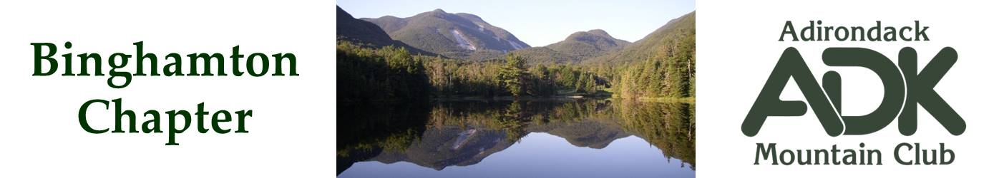

BINGHAMTON CHAPTER OF THE ADK
Meeting Minutes for 6/10/25

The June chapter meeting was held at Roundtop Park in Endicott. The night turned out to be sunny and warm with a great view over the Susquehanna. At the end of the meeting the group did a short hike around the main trail of the park.

Attendees were: Lindsey Leiser, Bob Strebel, Pat Connors, Brooks Getty, Dave Bailey, Devin McMicken, Seaver Wrisley, Kris Gilbert, Nick & Cindy Gretzinger.

Meeting discussions:

Chapter Camp Out at the Adirondack Loj Wilderness Campground August 21-24

Ideas and interest in hikes near the Loj were discussed. Provide further inputs to Nick Gretzinger (nickgretzinger@gmail.com) for additional hikes to consider. Nick will be compiling the list and will send out a daily itinerary for the trip. Other options include fire tower hikes nearby and paddling on Heart Lake (Rental boats available).

Chapter Budget

Lindsey reported on the current budget ($1677) with payments for recent speakers, and an addition in May from the main club. The next addition from the club is due in the July/August time frame.

Conservation Projects

Bob and Patsy Strebel completed a sweep of the trails at Jenksville State Forest. Trails are in good shape.
Brooks reported that the Jenksville DEC ranger has moved on to another job, and will find out who the new contact will be when available. Other possible projects were discussed and are tbd.

Events

In October the Broome County Riverbank Clean Up is usually scheduled for the 2nd or third week. We will send out a date when it is announced.

On November 4th, Randi Minetor is scheduled to speak – this may coincide with election day activities. Lindsey will check and verify.

The holiday party was also discussed as potentially having it at the Beer Tree again by popular demand. Date tbd.

Next Meeting September 16th, location TBD

Cindy Gretzinger
Binghamton ADK Chapter Chair

