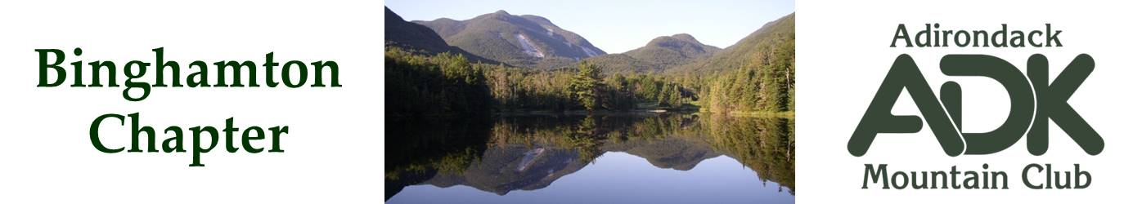

BINGHAMTON CHAPTER OF THE ADK
Meeting Minutes for 10/7/25

The October chapter meeting was held at the Chenango Town Hall.

Attendees: Lindsey Leiser, Bob Strebel, Pat Connors, Dave Bailey, Tom Moberg, Nick Gretzinger and Cindy Gretzinger.

Treasurer Report
Lindsey reported the current treasury amount is $2898.

Membership Report
13 new members added since June.

Officer Elections for 2026-7 Term
A nomination committee was formed. Please send nominations to Dave Bailey, Brooks Getty, or Nick Gretzinger. Nominations close on November 4th. Voting starts on November 5th. Elections complete on Dec 31st.

Winter and Summer Campouts
Bob will set up a winter chapter outing at the ADK LOJ or Wiezel Cabin sometime in February or March.

Nick will set up a summer chapter outing at the JBL. Date is TBD, but likely in August.

Scheduled Events
October 18th, Broome County Riverbank Clean Up. The chapter will meet at our traditional spot at the south side of Otsiningo Park at 9AM.

November 4th, Randi Minetor is scheduled to speak.

The holiday party will be at the Beer Tree again by popular demand. Date TBD, but between Dec 2-4.

Actions
Cindy - Advertise Nov 4 Randi Minetor presentation with TCHC and Ahwaga Canoe Club.

Cindy - Reserve Beer Tree for holiday party for the first Tuesday, Wednesday, Thursday in December.

Bob - Make ADK LOJ reservation for winter outing.

Nick - Make JBL reservation for summer outing (early 2026).

Nick Gretzinger
Binghamton ADK Secretary

