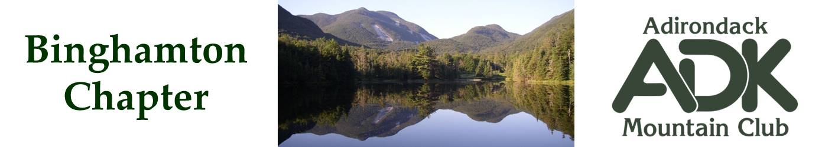

BINGHAMTON CHAPTER OF THE ADK
Meeting Minutes for 1/6/26

The January 2026 chapter meeting was held in the Scott Room at the George F. Johnson Library, Endicott.

Attendees: Lindsey Leiser, Bob Strebel, Pat Connors, Dave Bailey, Devin McMicken, Brooks Getty, Nick Gretzinger and Cindy Gretzinger.

New Officers for 2026-7 Term
The election for chapter officers for 2026-2027 is finalized. See the chapter webpage for current officers.

New Officer Roles and Responsibilities
The Secretary will send out meeting minutes to officers prior to the next meeting. The minutes will be accepted by Robert’s Rules of Order at the following meeting. The Membership Officer will run a report of new chapter members every couple of months. The mailing list will then be updated.

Treasurer Report
Lindsey reported the current treasury amount is $2559

Chapter Bylaws
Our chapter bylaws were published in 2009 and need to be reviewed. There may be updated, recommended bylaws available from the main club. Bob, Cindy and Dave to review options offline.

Advisory Council Report
Bob mentioned that the main club has several interesting events on their website calendar. The Susquehanna chapter is hosting the annual jamboree in 2027. They are looking for help. About 4 people expressed interest in helping.

Programs Report
Lindsey is having trouble getting speakers. It was brought up that the Executive Director might give a presentation, possibly in coordination with other nearby chapters. Lindsey will resend emails one more time to most promising speakers, and look into some options at local nature centers, e.g.:
- The Wolf Mountain Nature Center
- Rogers Environmental Education Center
- Cornell Lab of Ornithology

Winter and Summer Outings
Bob has 17 people attending the ADK LOJ outing in March.

Nick will set up a summer chapter outing at the JBL for August 28-31. Fourteen bunks will be reserved.

Conservation
Brooks will set up a trail cleanup for Rock Rift. April or early May is the preferred timeframe.

Other Scheduled Events
The next chapter meeting is Feb 3rd at the George F. Johnson Library, Endicott, NY.

Further chapter meetings;
- Apr 7th – chapter meeting at the George F. Johnson Library, Endicott, NY.
- May 6th – TBD, dependent upon getting a speaker.
- Jun – TBD, possibly at a local park.
- Oct 6th - TBD
- Nov 4th – TBD.

There will be NO March meeting.

Cindy will give a presentation about ADK and our chapter at the Binghamton University Lyceum on Apr 13th. Others are welcome to participate if interested.

Dave Bailey
Binghamton ADK Secretary

