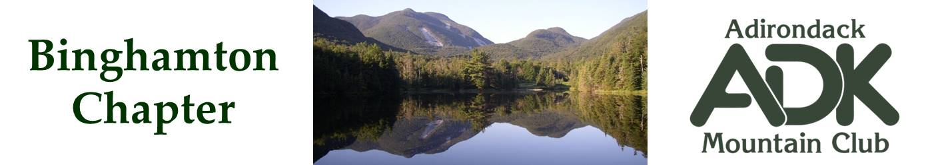

BINGHAMTON CHAPTER OF THE ADK
Meeting Minutes for 2/3/26

The February 2026 chapter meeting was held in the Scott Room at the George F. Johnson Library, Endicott.

Attendees: Lindsey Leiser, Pat Connors, Dave Bailey, Devin McMicken, Brooks Getty, Larry Blumberg, Nick Gretzinger and Cindy Gretzinger.

January Meeting Minutes
The meeting minutes from the January 6th meeting were unanimously accepted.

Membership Report
Pat is working to get the membership report so that the email listing can be kept up to date.

Treasurer Report
Lindsey reported the current treasury amount is $2559

Programs Report
Tony Goodwin will present at the May 6th meeting. Lindsey is working to get Edward G Henry to present at the November 4th meeting. Lindsey will set up an outing at the Cornell Lab of Ornithology this spring.

Winter and Summer Outings
Nick has set up a summer chapter outing at the JBL for August 20-23. Fourteen bunks are reserved and 10 people have signed up so far.

Conservation
Brooks has reached out to Laurie Rankin regarding the Rock Rift fire tower restoration. We should know if help is needed by June. Otherwise, we will do a standard sweep of the Rock Rift trail. April or early May is the preferred timeframe.

Triple Cities Hiking Club will be doing trail maintenance at Hawkins Pond on national trails day (June 6). Cindy will reach out to Brenda Gow for approval.

Chapter Bylaws
Dave Bailey, Bob Strebel, Cindy Gretzinger and Pat Connors are on the bylaw committee. We need to think about how to get any possible revised bylaws approved.

Other Scheduled Events
The next chapter meeting is Apr 7rd at the George F. Johnson Library, Endicott, NY.

Further chapter meetings;
- May 6th – Chenango Town Hall.
- Jun – TBD, possibly at a local park.
- Oct 6th - TBD
- Nov 4th – TBD.

There will be NO March meeting.

Cindy will give a presentation about ADK and our chapter at the Binghamton University Lyceum, 1:00-3:00pm on Apr 13th at WSKG on Gates Road in Vestal. She gave a dry run presentation at this meeting.

Consideration should be given to having an online option for the next applicable meeting.

Dave Bailey
Binghamton ADK Secretary

