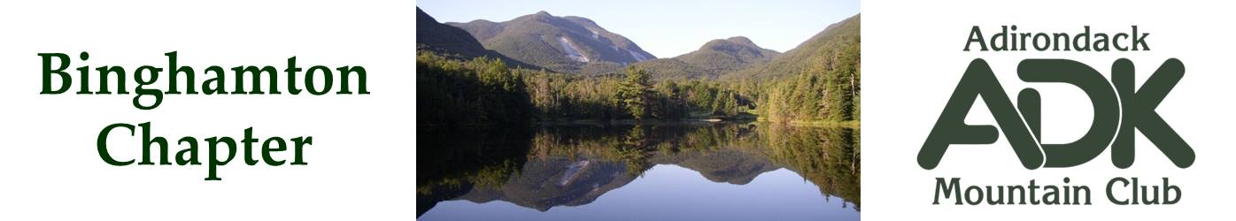

BINGHAMTON CHAPTER OF THE ADK
Meeting Minutes for 4/7/2026

The April 2026 chapter meeting was held in the Scott Room at the George F. Johnson Library, Endicott.

Attendees: Lindsey Leiser, Dave Bailey, Devin McMicken, Brooks Getty, Larry Blumberg, Bob Strebel, Nick Gretzinger and Cindy Gretzinger.

February Meeting Minutes
The minutes for the February 3rd meeting were unanimously accepted.

Membership Report
Cindy reported that the latest Chapter membership is 158.

Treasurer Report
Lindsey reported the current treasury balance is again $2559.28.

Programs Report
Tony Goodwin, son of Jim Goodwin and current editor of the ADK High Peaks Trails and Guide Map, will present during our meeting at the Chenango Town Hall on Wednesday, May 6^{th,} at 7:00pm. The club will reimburse him $225 toward his travel expenses from Keene Valley. We will invite members of the Triple Cities Hiking Club and nearby ADK Chapters to join us.

Lindsey reviewed possible agendas for an Level 1 outing at the Cornell Lab of Ornithology on May 2, and Dave will seek approval from Josh Ellis, Executive & Development Associate of the ADK.

Winter and Summer Outings
Nick has set up a summer chapter outing at the JBL for August 20-23. Fourteen bunks were reserved and 10 people signed up. By April 12, they each must decide whether they want to stay an provide their own meals, opt in to the JBL meal plan at $81 per night, cancel the bunk and tent nearby instead, or cancel their reservation altogether.

Conservation
Cindy will seek markers for the Hawkins Pond Trail, and some of our members will survey the site in early May.

Bob will survey interest in backpacking to the Tirrel Pond Lean-To.

Brooks reached out to Laurie Rankin of the <organization> regarding the Rock Rift fire tower restoration. We will learn what we can do to help after their board meets on June 1. We may simply perform a standard sweep of the Rock Rift trail.

Chapter Bylaws
Dave Bailey, Bob Strebel, Cindy Gretzinger and Pat Connors are on the bylaw committee. Cindy compared ours to other Chapters’ bylaws and will share her first pass of markups with them to review and comment.

ADK
Bob provided some insight to pending updates for Trip Leader Guidelines and Outdoor Leader Training: The ADK Outings Committee is providing recommendations to the Staff as they revise the policies.

Cindy completed her presentation about the Club and our Chapter for the Binghamton University Lyceum, 1:00-3:00pm on Apr 13th at WSKG on Gates Road in Vestal.

Other Scheduled Events
The next chapter meeting is 7:00PM May 6th at the Chenango Town Hall.

Further chapter meetings:
- Jun – TBD, possibly at a local park.
- Oct 6th - TBD
- Nov 4th – TBD.

Dave Bailey
Binghamton ADK Secretary

